- Developments in the Middle East pushed the long end of the gilt curve to multi-year highs this week. Renewed hopes of a peace deal led yields to drop back, but the rise since the conflict began has been much larger in the UK than elsewhere. This reflects the turnaround in market expectations for Bank Rate, with markets swinging from pricing a couple more cuts to anticipating two to three hikes in the next year.
- If the peace talks result in traffic flows in the Strait of Hormuz gradually normalising, bringing oil and gas prices down in H2, then we expect Bank Rate will stay on hold. This should gradually bring down the longer end of the curve. But with the local election results appearing to be as bad as Labour feared, raising the risk that Keir Starmer must stand down, elevated political risk could raise term premia and keep yields high.
It’s been another volatile week in financial markets, driven by developments in the Middle East. Hostilities temporarily resumed on Tuesday and at one point, the UK 30-year gilt yield touched 5.8%, its highest level since 1998, while the 10-year yield moved close to the 18-year high it hit a few weeks ago.
News that the US was pausing its plan to guide ships through the Strait of Hormuz and that peace talks were progressing subsequently led yields to fall back. But at market close on Thursday, the 10-year yield was still 66bps higher than it was before the conflict began. This is comfortably the biggest increase among the major advanced economies (Chart 1).
Chart 1: The increase in 10-year government bond yields has been much larger in the UK than elsewhere
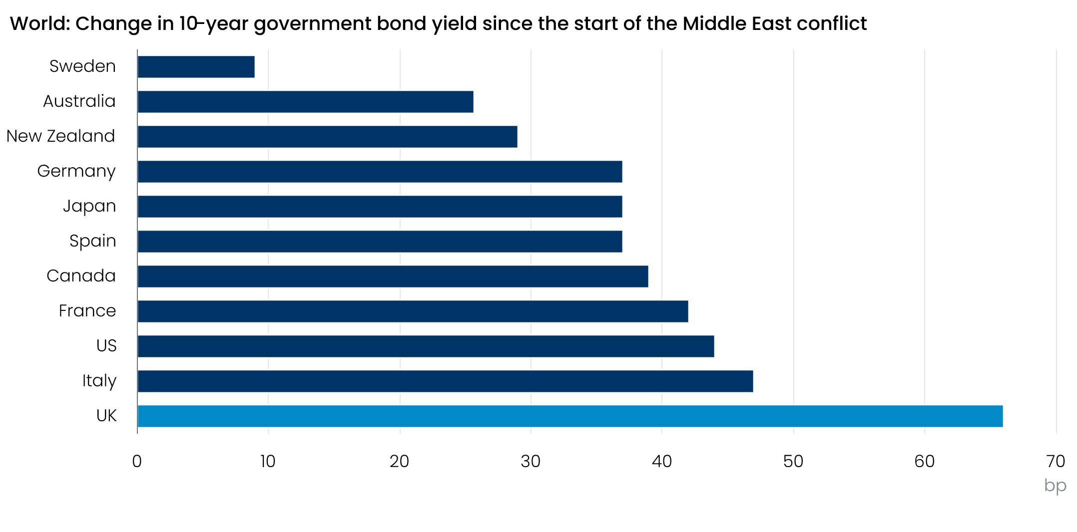
Source: Oxford Economics calculations using data from Haver Analytics

The bulk of the increase in the UK 10-year yield has been led by movement at the shorter end. Before the conflict began, markets were pricing a little over two 25bp cuts to Bank Rate by the end of this year. Now, markets price two 25bp hikes this year, with a further half a hike priced for the first half of 2027 (Chart 2).
Chart 2: Markets price between two and three 25bp rate hikes over the coming year
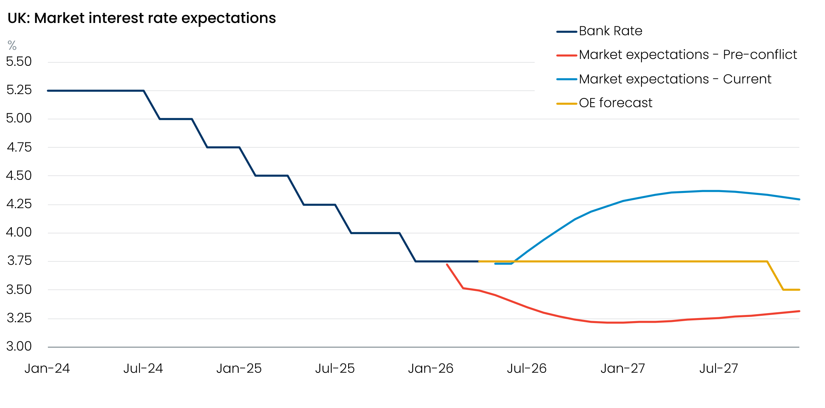
Sources: Oxford Economics, Haver Analytics
The inflationary outlook has changed markedly because of events in the Middle East, and the experience of the past few years has left the impression that the UK is particularly vulnerable to an energy shock. But if the two sides come to an agreement that allows traffic flows to resume in the Strait, causing oil and gas prices to fall back, then we expect the Bank of England will keep policy unchanged, rather than hike rates. This should gradually pull yields lower across the curve. But that scenario is far from certain, and as we argued in our reaction to last week’s Monetary Policy Committee meeting, the risks are skewed towards some modest tightening in the summer.
The other factor that could keep yields high at the longer end of the curve is domestic political developments. We’ve long identified this week’s local elections as a potential trigger. At the time of writing, most results are still to be declared, but early indications are that the results will be every bit as bad as the governing Labour party feared they would be. This will ratchet up the pressure on Prime Minister Keir Starmer.
If Starmer tries to fight on, he will have to try something new to try to boost his popularity. This could include a near-term fiscal loosening to try to cushion the blow of higher energy prices and reduce the risk of recession. But such a move would risk denting his credibility with markets, who have given him the benefit of the doubt so far.
The chances of Starmer being forced to stand down are high. But such a departure might not happen immediately. Potential successors, Angela Raynor and Andy Burnham, have incentives to delay the start of a leadership contest. There may also be a desire to wait for a resolution of the Middle East conflict. So it’s possible that the Prime Minister could set a timetable to stand down later in the year.
As we set out in a recent note, all of the potential candidates for Labour leadership imply a change in economic policy priorities. The UK’s parlous fiscal situation means markets are likely to be wary of those advocating a more left-wing economic approach. So there’s potential for rising term premia to keep bond yields high, even if expectations for Bank Rate drop back. We will look at these issues in more detail and analyse the consequences of elevated gilt yields in an upcoming Research Briefing.

The week ahead
Next week’s only major release is the March GDP data, which will complete the picture for Q1. February saw an extraordinary 0.5% m/m increase in GDP, and several of the sectors that drove that outsized rise look ripe for payback in March. But on the flip side, there’s still strong evidence of residual seasonality in the data, with our analysis suggesting that the Office for National Statistics’ seasonal adjustment process is not fully accounting for a structural shift in the seasonal pattern of expenditure towards Q1 since the pandemic.
So we anticipate only a partial reversal of February’s surge. We pencil in a 0.2% m/m drop in GDP in March, which would leave quarterly GDP growth at 0.5%-0.6% for Q1.
Table 1: Week ahead calendar
Date | Events | Period | Measure | Unit | Previous | Forecast
May 14 | GDP | Mar | m/m | % | 0.5 | -0.2
May 14 | GDP | Mar | 3m/3m | % | 0.5 | 0.5
May 14 | Index of services | Mar | m/m | % | 0.5 | -0.2
May 14 | Index of services | Mar | 3m/3m | % | 0.5 | 0.6
May 14 | Manufacturing output | Mar | m/m | % | -0.1 | 0.0
May 14 | Manufacturing output | Mar | y/y | % | -0.5 | 0.2
May 14 | Industrial production | Mar | m/m | % | 0.5 | -0.4
May 14 | Industrial production | Mar | y/y | % | -0.4 | 0.1
May 14 | Construction output | Mar | m/m | % | 1.0 | 0.4
May 14 | Construction output | Mar | y/y | % | -1.0 | -1.5
May 14 | UK trade | Mar | Trade balance | £bn | -0.7 | -2.0
May 14 | UK trade | Mar | Visible balance | £bn | -18.8 | -20.1
Source: Oxford Economics

Key forecasts
Table 2: UK forecast overview
(ANNUAL PERCENTAGE CHANGES UNLESS SPECIFIED)
 | 2023 | 2024 | 2025 | 2026 | 2027 | 2028
GDP | 0.3 | 1.1 | 1.4 | 0.6 | 0.8 | 1.7
Private consumption | -0.3 | -0.1 | 0.8 | 0.4 | 0.4 | 1.4
Fixed investment | 0.5 | 1.8 | 4.3 | 0.2 | 1.4 | 2.6
Government consumption | 2.1 | 2.9 | 1.7 | 1.9 | 1.6 | 1.4
Consumer prices | 7.3 | 2.5 | 3.4 | 3.9 | 2.7 | 1.9
Unemployment rate (%) | 4.1 | 4.3 | 4.9 | 5.3 | 5.4 | 4.9
Current a/c balance (% of GDP) | -3.6 | -3.0 | -2.4 | -3.2 | -3.1 | -2.6
Government balance (% of GDP) | 5.2 | 5.2 | 5.1 | 4.2 | 3.6 | 2.9
Central bank policy rate (%, EOP) | 5.25 | 4.75 | 3.75 | 3.75 | 3.50 | 3.00
10yr govt. bond yield (%, EOP) | 3.54 | 4.57 | 4.47 | 4.73 | 4.20 | 3.83
Exchange rate (US$ per £, EOP) | 1.27 | 1.25 | 1.35 | 1.29 | 1.30 | 1.30
Exchange rate (euro per £, EOP) | 1.15 | 1.21 | 1.15 | 1.11 | 1.10 | 1.10
Source: Oxford Economics
Table 3: Quarterly forecasts for the UK
 | 2025 |  |  |  | 2026
 | Q1 | Q2 | Q3 | Q4 | Q1 | Q2 | Q3 | Q4
GDP (% year) | 1.8 | 1.4 | 1.3 | 1.0 | 0.9 | 0.7 | 0.5 | 0.5
CPI inflation (% year) | 2.8 | 3.5 | 3.8 | 3.4 | 3.1 | 3.7 | 4.4 | 4.4
Bank Rate (%, EOP) | 4.50 | 4.25 | 4.00 | 3.75 | 3.75 | 3.75 | 3.75 | 3.75
10yr gilt yield (%, EOP) | 4.70 | 4.48 | 4.70 | 4.47 | 4.88 | 4.80 | 4.79 | 4.73
US$ per £ (EOP) | 1.29 | 1.37 | 1.35 | 1.35 | 1.32 | 1.31 | 1.30 | 1.29
Euro per £ (EOP) | 1.20 | 1.17 | 1.15 | 1.15 | 1.14 | 1.14 | 1.12 | 1.11
Source: Oxford Economics

Latest Country Economic Forecast:
April 20, 2026

Recent publications

Data Insights
Pickup in the PMI won’t last
Mortgage activity strengthened in March, despite higher interest rates
Manufacturing PMI rise masks weakness
March retail bounce too good to be true
Activity growth is likely to slow sharply, despite rebound in April’s flash PMIs

Research Briefings
MPC maintains a watching brief, but chances of higher rates are rising
Residual seasonality issues continue to flatter activity growth in Q1
MPC preview – Maintaining the ‘wait and see’ message
What different migration profiles mean for the economy and public finances
Why higher rates may be on the MPC's agenda

Contacts

Oxford Economics' UK team
- Andrew Goodwin – Chief UK Economist – agoodwin@oxfordeconomics.com
- Edward Allenby - Senior UK Economist - eallenby@oxfordeconomics.com

